Teachers’ Bedtime Stories
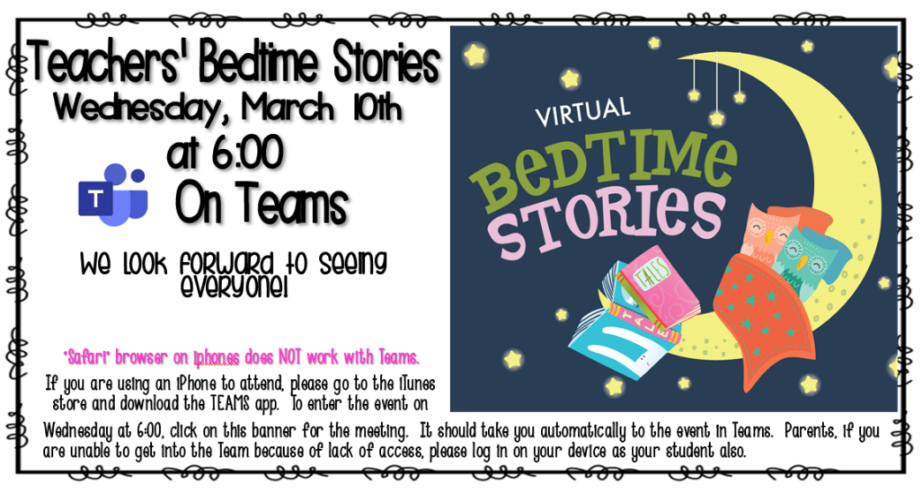
As a part of the Panda Cares New Teacher Fellowship with Panda Express, I am required to create a family literacy event. With the help of the fellowship program, I was able to organize my school’s first “Teacher’s Bedtime Stories” event. This was a virtual bedtime story event on March 10,2021 and it was a raving success. The teachers’ bedtime stories program was created with families in mind. The event was open to all students that attend Monte Sano Elementary. Monte Sano Elementary serves students from Pre-K through 5th. Students were encouraged to have younger and older siblings to attend as well.

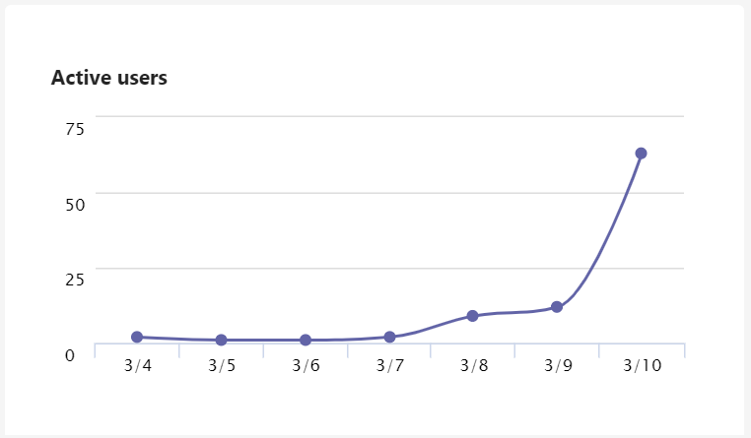
Due to COVID-19 and concern for safety, we held the event virtual. Our school’s population is a mixture of online or face to face students. We held the event on Microsoft Teams because this is the platform using for online and face to face. I created a team in Microsoft Teams titled “Monte Sano Bedtime Stories”. Monte Sano Elementary is located in the middle of the Summerville Historic District. “Monte Sano Elementary School, established in 1893, is one of the oldest schools in Richmond County. In the school 67% of students are economically disadvantaged and 33% of students are not economically disadvantaged (Governor's Office of Student Achievement, 2021). Monte Sano Elementary allowed parents to get laptops for online learning and jetpacks for internet if the family did not have internet at home for online learning. So, our concern was more online students would attend versus face to face students. However, the events attendance showed a mixture between online and face to face students.

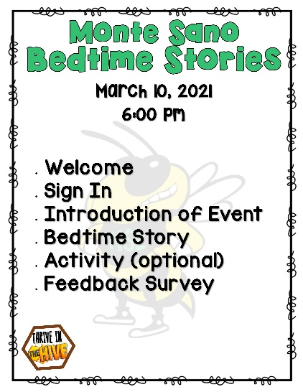
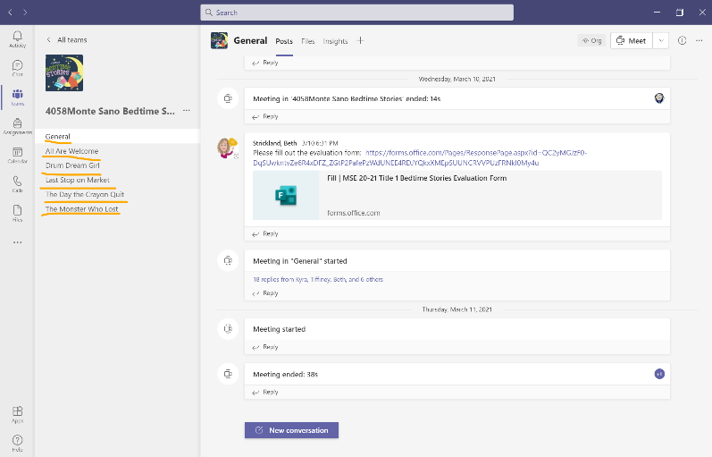
When families logged into the event they were in the general channel. We welcomed the families attending. The students and parents were so excited to see the faculty and staff that we gave them 5 minutes to get their “hellos” out. Once the event started a sign-in survey link was added in the chat box. We walked families through how to complete the sign-in survey. If families were having issues with completing the survey, families were assisted by a faculty or staff member. We allowed 5 minutes for survey completion. Once surveys were complete, we introduced the event and how to enter the channels for the books. If families were having issues with completing the survey, families were assisted by a faculty or staff member.
The Microsoft team created for the event included five channels. The channels were labeled by book titles, so families choose the book they wanted to listen to. If families were logged into multiple devices, they were able to listen to multiple books. Each channel had three faculty and staff members. The faculty and staff members read the book, shared their screen to display the book, or announced raffle winners. Some teachers had activities for students to complete after reading the book. For instance, the teacher who read The Monster Who Lost His Mean had families draw a monster after reading the book. The teacher who read Drum Dream Girl had families do drumming movements with her as she read the book. The teachers who read All Are Welcome, Last Stop on Market Street, and The Day The Crayons Quit had families complete a 5 finger retell for students Pre-K – 2nd grade and a book report for 3rd-5th grade. These were activities we printed and sent home with every Face-to-Face student the day of the event and post in SeeSaw for our virtual students. Once the book was read and activities were complete families were entered into a raffle to win the book that was read. The faculty and staff sent a survey for families to complete before leaving the event.
After the event, I had some reflection moments there are a few things I wish I would have done differently. I wish we would have set up the Microsoft team as a class versus a club. The club set restrictions for who could join the team. I would have spent more time with completing the sign in survey. We had 70 plus attendees, but only 30 attendees signed in. Also, I wish I would have done a practice run with the teachers because some teachers had issues joining or sharing their screen. I know this was outside of my control because time is not always in our favor.
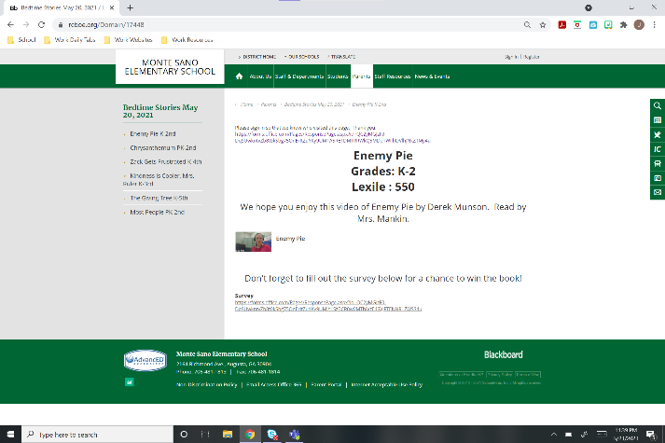
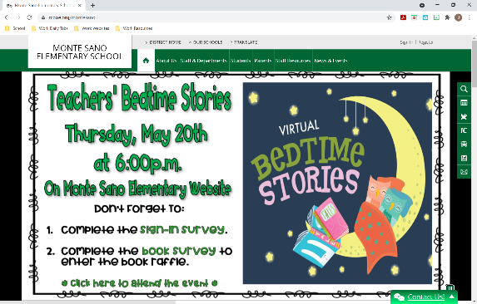
Since the Bedtime stories was such a success and several families, faculty, and staff members asked about a second event we decided to host the event again. The issue was we were only able to hold the event again in May, which was the end of the year so we had state testing, honors day, field’s day, technology turn in for online students, and end of the year. So our time was limited so we decided to post the event on the schools website to make it easier for families to view. Families were able to choose between five books. The families were able to view all five books if they wanted. The books pages included a sign-in survey, video of teacher reading the book, and survey to enter raffle to win book. We left the event on the website for two weeks because we had honors day posting the same week so we wanted families to be able to view the event at their leisure. The website statistics shows it was only viewed ten times, which is an extremely low turn out. Positively, we were able to give the raffled books away to those who did attend. If I had the option I would have done this event online like I did for the first event, because there was a better turn out. I do feel having an online community did allow the first virtual event to be successful as it was. Overall, I am very excited for the individual success of both events.

